Assessment Brief

|  |  |
| --- | --- |
| Student Name/ID Number | Francis Roel L. Abarca – BDSE-0922-113 |
| Unit Number and Title | S: Security |
| Academic Year | 2023-2024 |
| Unit Tutor | Christ Evvert Lisangan |
| Assignment Title |  |
| Issue Date | 2/17/2024 |
| Submission Date |  |
| IV Name & Date |  |

|  |
| --- |
| **Submission Format** |
| The submission is in the form of a ten-minute Microsoft® PowerPoint® style presentation to be presented to your colleagues. The presentation can include links to performance data with additional speaker notes and a bibliography using the Harvard referencing system. The presentation slides for the findings should be submitted with speaker notes. You are required to make effective use of headings, bullet points and subsections as appropriate. Your research should be referenced using the Harvard referencing system. The recommended word limit is 500 words, including speaker notes, although you will not be penalised for exceeding the total word limit. |

1. **Introduction**

In today’s fast-paced retail environment, providing excellent customer service is essential for building trust and loyalty. One way to achieve this is by utilizing AI chatbots to reduce costs, increase efficiency, and personalize interactions. This project aims to design and implement a self-hosted AI chatbot prototype for Jumpstart, using LLaMA 2 to integrate with their REST API and provide information about stock and product description. The chatbot will be evaluated and tested with real users, and the feedback and metrics will be analyzed to measure customer satisfaction, engagement, and loyalty. Additionally, the project will explore the best practices and examples of successful AI chatbots in retail, such as those utilized by H&M and Tommy Hilfiger. By running the chatbot on our own systems instead of relying on other APIs, we can ensure greater security, trust, control, reliability, and lockdown of the system. Only the people involved will have access to it. This project has the potential to revolutionize the way Jumpstart interacts with its customers and improve their overall experience.

**2.0 Scope**

The scope of this project includes the following:

• The benefits and challenges of utilizing AI chatbots for retail customer service such as reducing costs, increasing efficiency, personalizing interactions, and building trust.

• The design and implementation of an AI chatbot prototype for Jumpstart, using LLaMA 2 to integrate with their REST API and provide information about stock and product description.

• The evaluation and testing of the AI chatbot prototype with real users, and the analysis of the feedback and metrics to measure customer satisfaction, engagement, and loyalty.

• The best practices and examples of successful AI chatbots in retail, such as those utilized by H&M, Tommy Hilfiger and the like on how they use AI to provide advice to users, helpful comparisons and product recommendations.

**3.0 Objectives**

The objectives of this project are as follows:

• Conduct a literature review on the existing research and applications of AI chatbots in retail customer experience.

• Identify the key features and functionalities that an AI chatbot should have to meet the needs and expectations of retail customers.

• Develop an AI chatbot prototype for Jumpstart using LLaMA 2 and test its performance and usability with real users.

• Provide recommendations and suggestions for improving the AI chatbot prototype and its integration with Jumpstart’s systems.

**4.0 Milestones /WBS/Gant Chart**

The following milestones will be achieved during this project:

**5.0 Budget**

The following is the budget for this project:

|  | | **Item** |
| --- | --- | --- |
| Software | | * Meta’s LLaMA 2 AI * Spring Boot * ReactJS * Flask * MySQL Server   = $0 USD |
| Hardware | * AMD Ryzen 7 5800H Mini-PC * 16GB of DDR4 RAM * 512GB PCIe Gen3 NVMe SSD   = $300 USD | |
| Training | | * Inventory Management Training * AI Management * Systems Training   = $100 USD |
| Maintenance and upgrades | | * IT Tech Support * Pulseway Monitoring * DWService * Windows Admin Center   = $0 USD |
| Total | | = $400 USD |

**6.0 Risk**

| **Risk** | **Impact** | **Likelihood** | **Mitigation Strategy** |
| --- | --- | --- | --- |
| Data loss during migration | High | Low | Backup data before migration and test migration process |
| User resistance to new system | Medium | Medium | Provide thorough training and support to users |
| Software compatibility issues | High | Medium | Test software thoroughly before implementation and have a contingency plan in place |

**Testing Plan**

Type of test, Total no of test cases. Etc

Functional testing:

1. Unit testing

|  |  |  |  |
| --- | --- | --- | --- |
| Test Scenario ID | Test Case ID | Test Objective | Expected Results |
| TS001 | UT001 | User asks AI for the latest products available. | AI chatbot gives the latest products available at Jumpstart. |
| TS002 | UT002 | User asks AI to compare Product A to Product B. | AI should clearly compare product A from product B. |
| TS003 | UT003 | User orders an item. | User should see their ordered item inside the cart. |
| TS004 | UT004 | User asks AI for advice in terms of this product. | AI will give helpful advice to the user. |
| TS005 | UT005 | Admin checks for orders. | Admin should see the orders available. |
| TS006 | UT006 | Admin checks for all available stocks. | Admin should see all the stocks stored in the database. |

1. Integration testing

|  |  |  |  |
| --- | --- | --- | --- |
| Test Scenario ID | Test Case ID | Test Objective | Expected Results |
| TS007 | IT001 | Admin should post a product to the database. | Admin’s product should show up on the home page and search. |
| TS008 | IT002 | Admin deletes a product from database. | The product gets deleted and revoked. |
| TS009 | IT003 | User deletes an item from cart. | The item from cart gets deleted. |

1. User Acceptance testing

|  |  |  |  |
| --- | --- | --- | --- |
| Test Scenario ID | Test Case ID | Test Objective | Expected Results |
| TS0010 | UAT001 | To access Chatbot easily. | User should be able to easily find the Chat button. |
| TS0011 | UAT002 | To place orders for a product. | User should be able to place orders easily. |
| TS0012 | UAT003 | To delete all items from cart. | User should be able to delete all items from cart. |

Non-Functional testing:

1. Portability testing

|  |  |  |  |
| --- | --- | --- | --- |
| Test Scenario ID | Test Case ID | Test Objective | Expected Results |
| TS0017 | PB001 | Verify portability of community portal under mobile device breakpoints | Portal is portable under mobile device breakpoints (320px-480px) |
| TS0018 | PB002 | Verify portability of community portal under tablet device breakpoints | Portal is portable under tablet device breakpoints (481px-768px) |
| TS0019 | PB003 | Verify portability of community portal under laptop device breakpoints | Portal is portable under laptop device breakpoints (769px-1024px) |

1. Performance testing

|  |  |  |  |
| --- | --- | --- | --- |
| Test Scenario ID | Test Case ID | Test Objective | Expected Results |
| TS0020 | UB001 | Access the Chatbot page. | The chatbot page should load in less than 15 seconds. |
| TS0021 | UB002 | Access the Home Page. | The home page should load in less than 7 seconds. |
| TS0022 | UB003 | Access the Search Page. | The Search page should load in less than 7 seconds. |

1. Compatibility testing

|  |  |  |  |  |  |
| --- | --- | --- | --- | --- | --- |
| Test Scenario ID | | Test Case ID | Test Objective | | Expected Results |
| TS0023 | | CT001 | Open the Chatbot page in Google Chrome. | | Page should load just fine on Chrome. |
| TS0024 | | CT002 | Open the Chatbot page in Mozilla Firefox. | | Page should load just fine on Firefox. |
| TS0025 | | CT003 | Open the Chatbot page in Apple Safari. | | Page should load just fine on Safari. |
|  | | |

Database Design

Flowchart  
  
 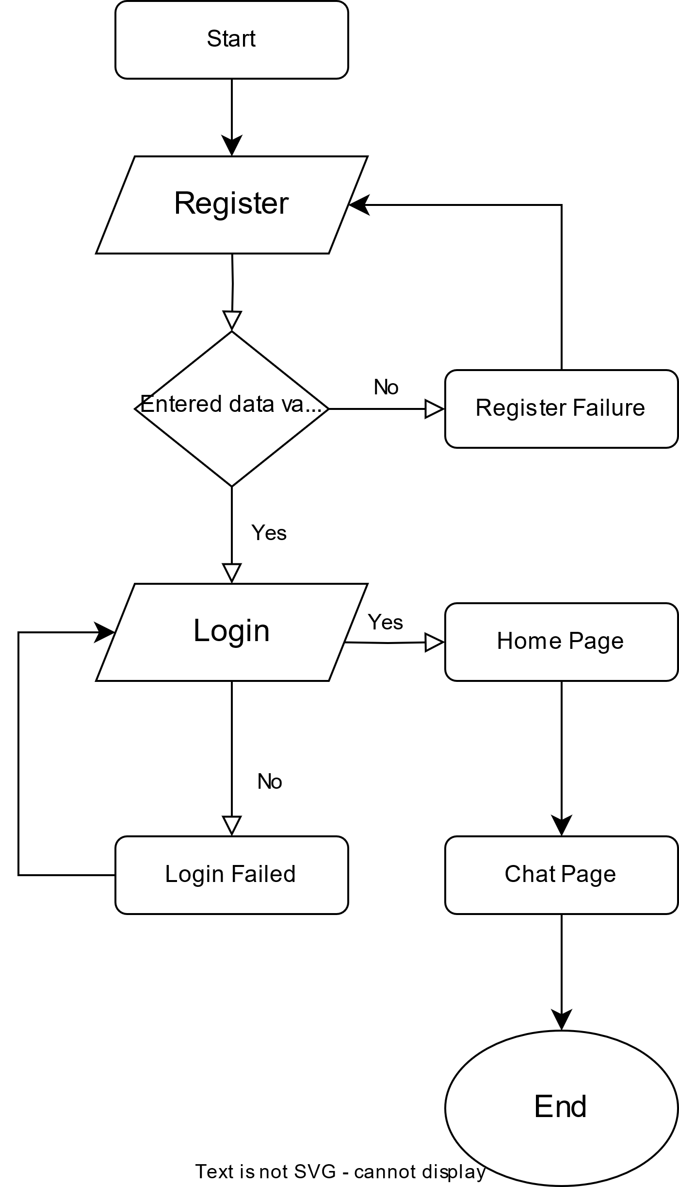

Storyboard 